**8 DELTA MODULATION AND DEMODULATION**

**8.1 Objective**

To analyze a Delta modulation system and interpret the modulated and demodulated waveforms**.**

**8.2 Hardware Required**

Ohm Delta Modulation & Demodulation Kit

Digital Storage Oscilloscope (DSO)

Patch Chords

**8.3 Introduction**

Delta Modulation is a form of pulse modulation where a sample value is represented as a single bit. This is almost similar to differential PCM, as the transmitted bit is only one per sample just to indicate whether the present sample is larger or smaller than the previous one. The encoding, decoding and quantizing process become extremely simple but this system cannot handle rapidly varying samples. This increases the quantizing noise.

**Block Diagram**

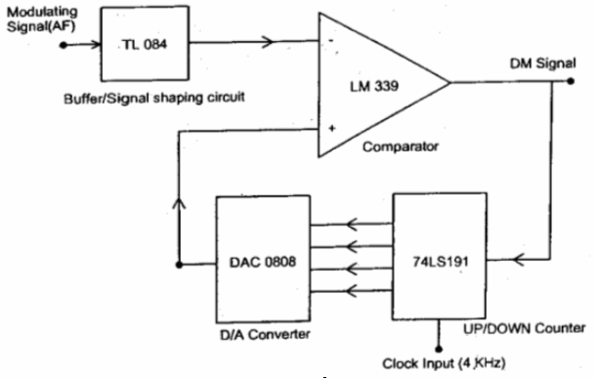

**Figure 8.1 DM Modulator**

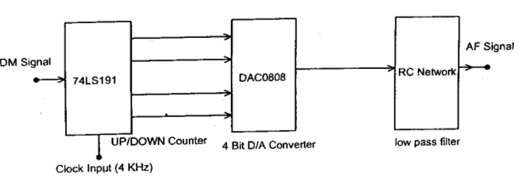

**Figure 8.2. DM Demodulator**

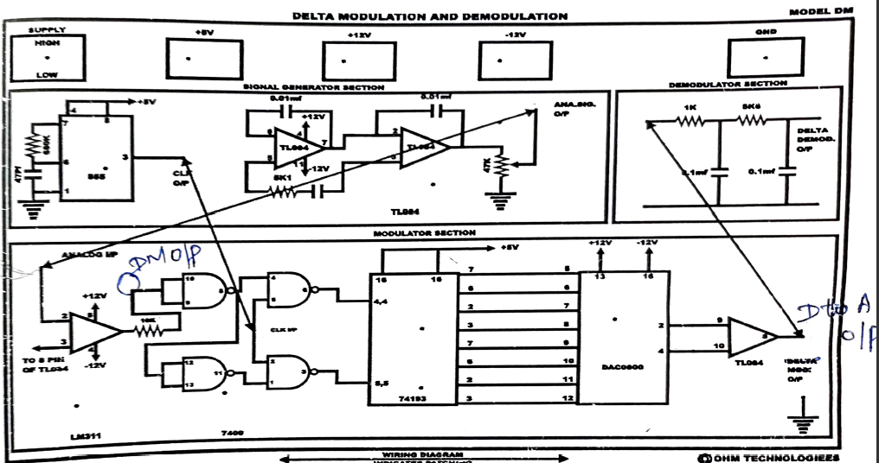

**Figure 8.3. DM Wiring diagram**

**8.4 Prelab Questions**

* 1. Write the features of IC 555.
  2. In this experiment, what function is carried out by IC 555.
  3. What is an up-down counter?
  4. What is DAC? What DAC IC is used in this experiment?

**8.5 Procedure**

1. Switch ON the trainer kit and check the DC power supply (+5V, +12V).
2. Patch the circuit until the DM modulation stage. Give the clock and analog signal as input to Delta Modulator (DM) as input.
3. Use the Digital Storage Oscilloscope to observe the clock and analog signal and note down the readings. Observe the DM output and note down the values.
4. Extend the patch till the DM demodulation stage.
5. Observe the output at the D to A as well as at the filter. Note down the readings and tabulate it.

**8.6 Model Graph**

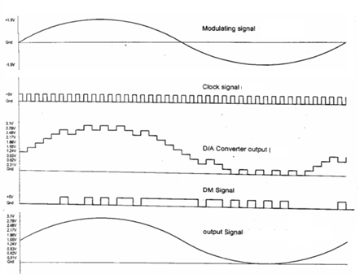

**Figure 8.4 DM Waveforms for AC input signal**

**Figure 8.5 DM Waveforms/Timing Diagrams with DC input**

**Observation**

**DM Modulation and Demodulation (With AC input)**

|  |  |  |
| --- | --- | --- |
|  | Amplitude | Time Period |
| Modulating Signal |  |  |
| Clock signal |  |  |
| DM Output* |  |  |
| D/A Converter Output |  |  |
| Demodulated Signal |  |  |

**\* Take Time Period for any one pulse.**

**8.7 Post Lab Questions**

1. Write the merits and demerits of Delta Modulation.
2. Where Delta Modulation is employed?
3. What are the noises that generated due to Delta Modulation?
4. The signal to quantization noise ratio (S/Nq) is 153.6. Express the value in dB.
5. What problems are mitigated in Adaptive Delta Modulation?

**8.8 Lab Result**

Thus, the Delta modulation and demodulation were performed using the trainer kit.